
INTELLECT 2K20
CATEGORY 1 – SCHOOL STUDENTS

S3 

Place | Name | Selected  Caption | Title | Caption
1 | B.S.BISHARAA | S3 | COLOURS ARE THE SMILES OF NATURE | INDIVIDUALLY WE ARE EACH ONE COLOUR, TOGETHER WE MAKE A RAINBOW COLOURS! WHAT A DEEP AND MYSTERIOUS LANGUAGE, THE LANGUAGE OF DREAM THE SOUL BECOMES DYED WITH THE COLOUR OF ITS THOUGHTS.

CATEGORY 2 – COLLEGE STUDENTS
C1 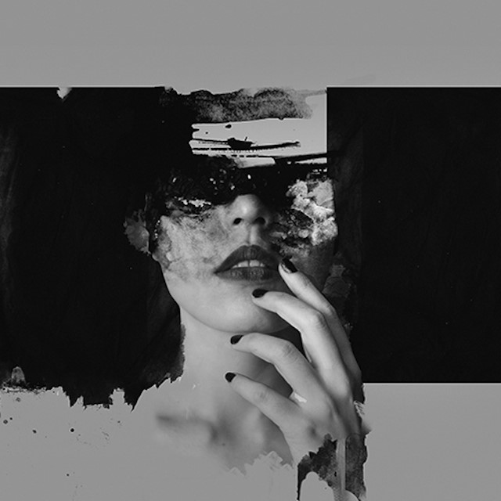 C2  C4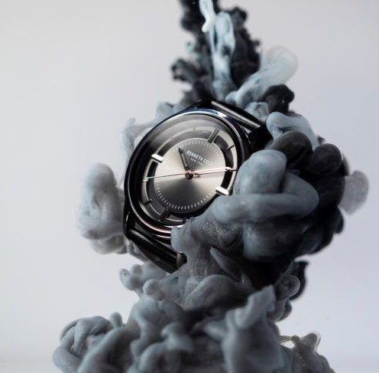

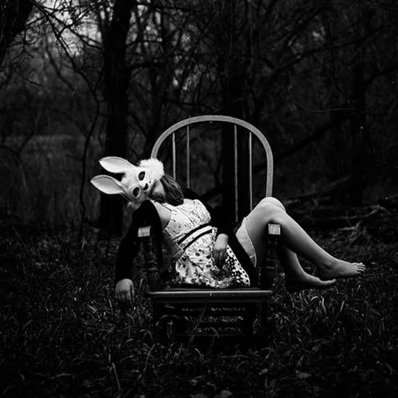
C5
Place | Name | Selected  Caption | Title | Caption
1 | PREKSHA JOSHI | C5 | Solitary Belief | Hang around sweet soul but remember not to contribute for it's bitterness.
2 | SUJAN GANESH | C1 | Grunge Thoughts | "Comprehending complex components composes a complex cerebral cortex. A gaudy heart and a grungy brain forge a great personage."
3 | WITNEY LISIEUX.S | C2 |  | Dusk- The sun's kiss to the night.
 |  | C5 |  | In Pretty Disguise, she lay.
 |  | C4 |  | Lost in time.

